**Caliban Job Type 1: Multicolor images**

**If you have not used the Caliban tool before, or have not worked on this specific job type before, please take the time to carefully read all instructions. If you are comfortable with the tool, skimming the examples to check what you need to fix may be all you need to complete the job. Different types of Caliban jobs use different tools, so you should read all instructions even if you've worked on a Caliban job before. If you are not sure about something, please reference the instructions. Thank you!**

**Overview**

In this task you will work with a tool to create annotations of densely packed cells in tissue. This tool, Caliban, has many features in it to help annotate and correct annotations. In this task, you will use a set of those features to create annotations of all the cells in the image.

**Background**

Our group is in the process of writing a computer program to automatically identify cells in tissue. To help us do this, we're asking you to help create annotated datasets where single cells are manually identified. We can then feed this into the computer program to teach it how to accurately identify cells by itself. This program will be used in other research laboratories to study a range of topics, including viruses, cancer cells, and immune cells.  **The software we create is only as good as the data used to create it, so accuracy in your annotations is extremely important.**

In this job, each file contains many cells. Many of the cells are already labeled correctly, but some cells in the file have labels that are too big, too small, or overlap adjacent cells. You will correct the labels with the provided tools.

**Your Task**

For this job, **your goal is to make sure that the border around each cell is in precisely the correct spot.**

**Algorithm Accuracy: High**

This means that **most** of the cells in this image are  correct. **Some** of the cells in this job will need to be changed.

**Specific Instructions for this job**

Many cells have been split into two pieces. You should combine them back together into one cell:

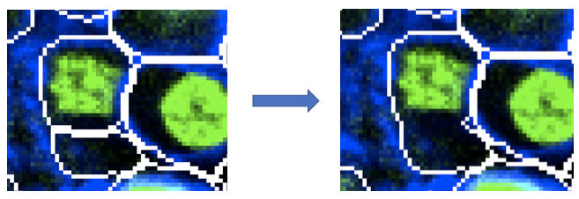

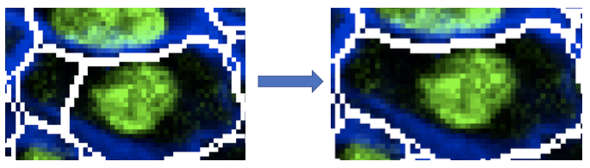

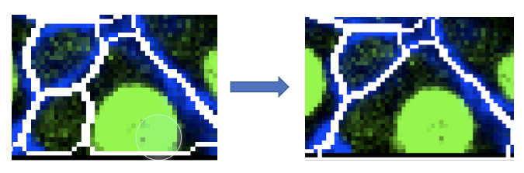

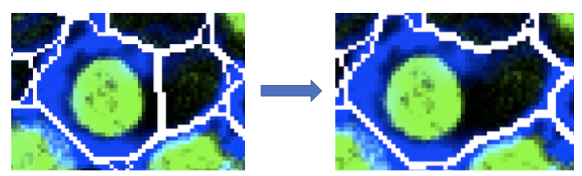

Many cells have only a blue part, and no green. That's okay, you should include those cells as well

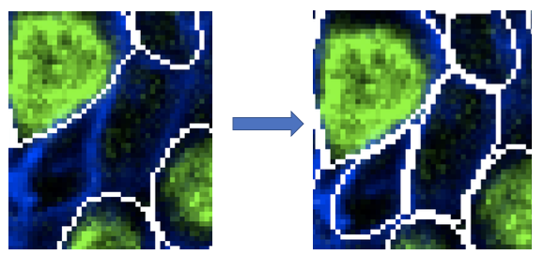

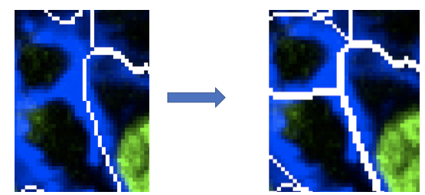

Some of the borders are in the wrong place:

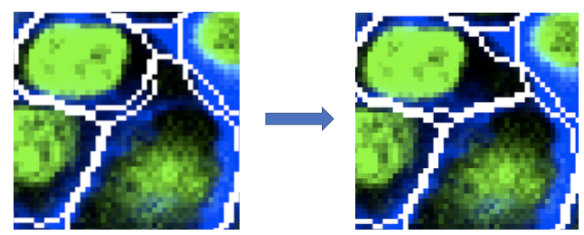

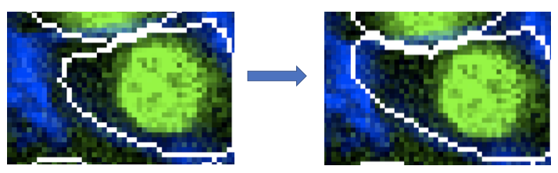

Some of the borders between adjacent cells aren't touching, and need to be expanded:

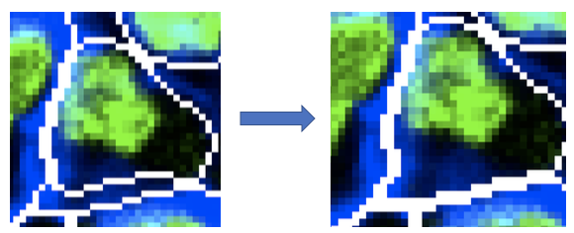

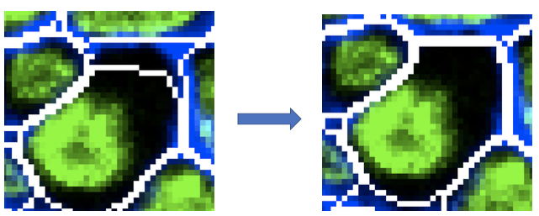

**General Instructions**

Too small

If a cell only has green, include all of the green and add a small gap around the outside:

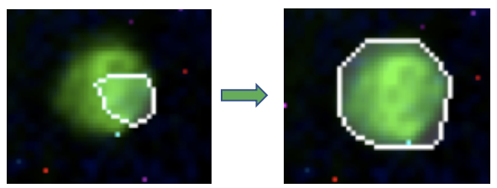

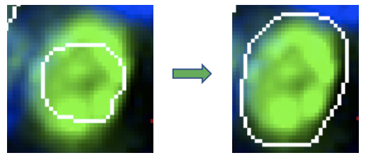

If a cell has green and blue, include both the green part and the blue part

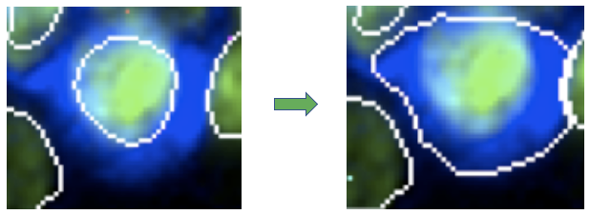

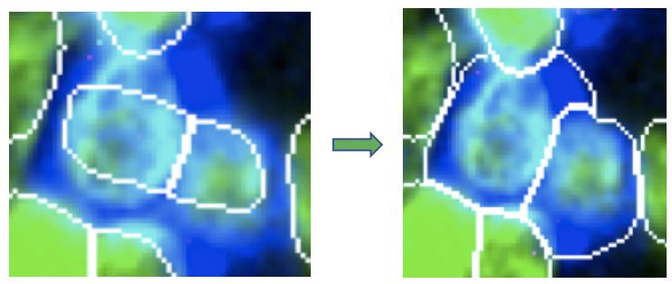

Too big

When the label is too big, you should shrink it so it only includes the cell. If a cell only has green, make sure that only the green is included, with a very small gap around the edge

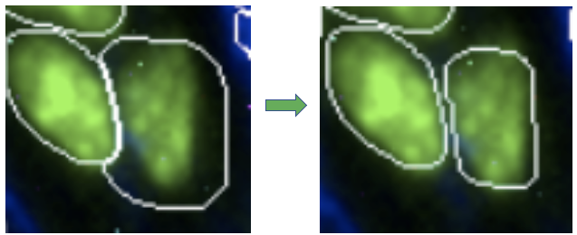

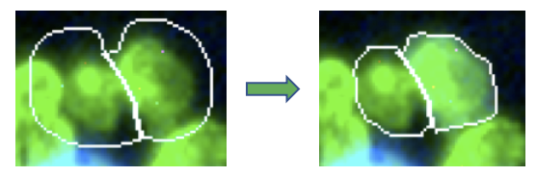

If a cell has green and blue, make sure the green and blue are included

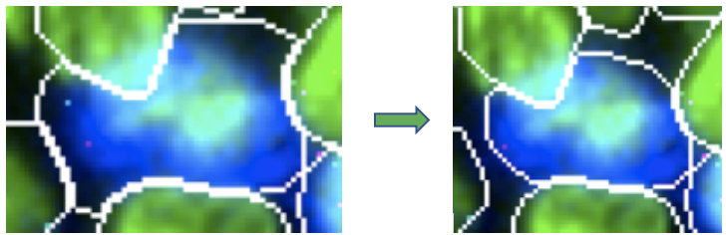

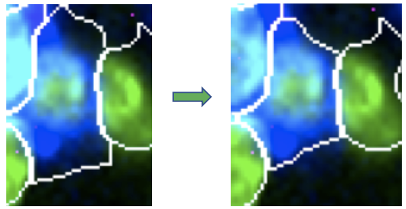

Overlapping adjacent cell

When the label from one cell overlaps another cell, you should fix it so that each cell has its own label

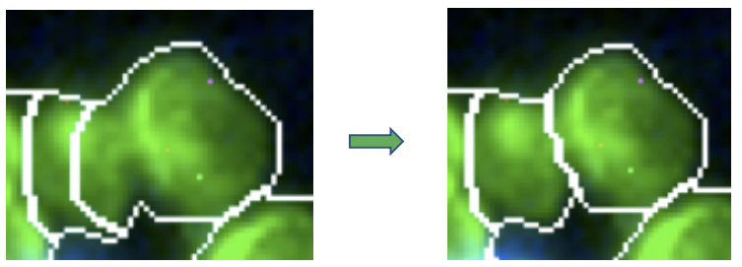

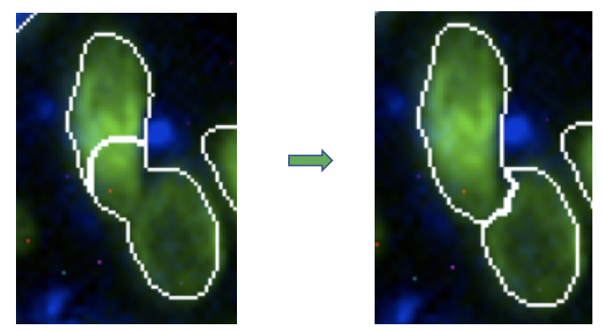

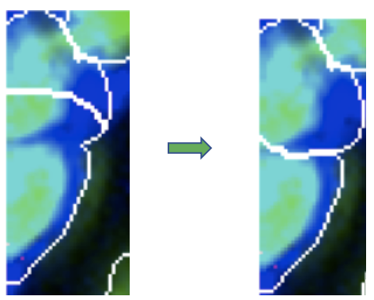

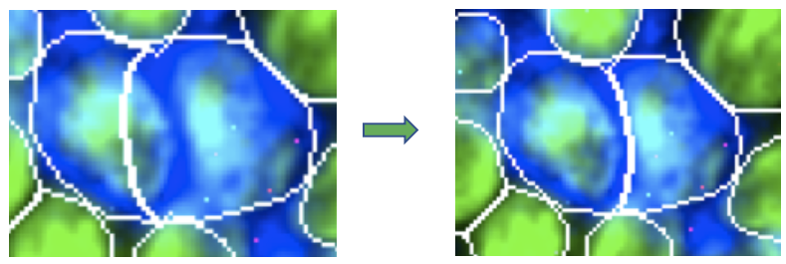

Cells with holes

If a cell has a label with a hole in the middle, fill in the hole

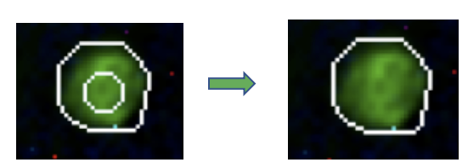

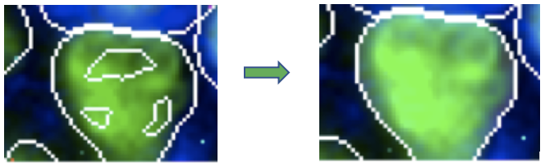

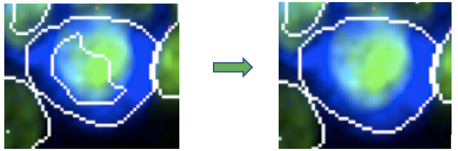

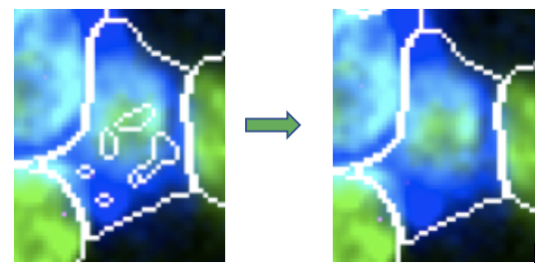

Missing cell

If a cell doesn't have a label, you should add one

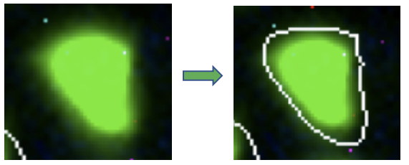

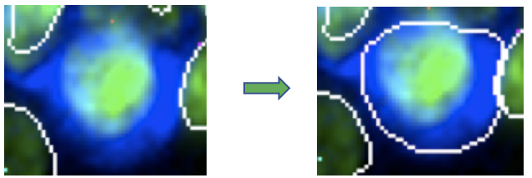

No cell

If a label exists but there's no cell there, you should delete it

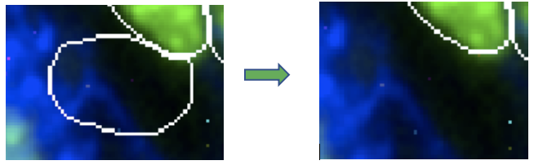  
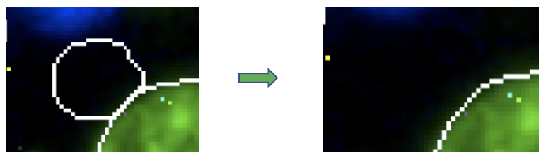

**How to Use Caliban Tools**

You will see a picture like this when the job starts. The right side shows images of cells, with the labels in white around each cell.  Messages will be displayed in the bottom left corner.  The current message is asking you to click on a cell to change the label:

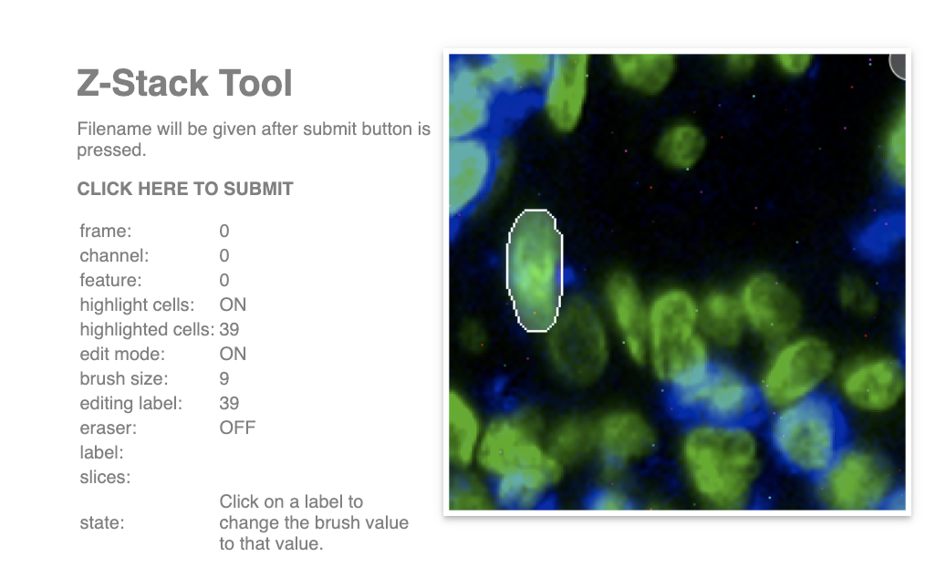

**Controls:**

To zoom in or out, hold the alt/option key and use the scroll wheel. To move around once zoomed in, hold down the space bar, then click and drag with the mouse.



**Change Brush Size:**Change the size of the brush with the up and down arrow keys.



We only show the outline around each cell, but every cell is its own full object:



**To draw**: To draw with the brush, click and hold down the mouse button. You'll see the outline of the object.



**Fill in the cells:**When you draw a circle with the brush, you'll need to fill it in afterwards, so that the whole cell is labeled.



The brush only works on the current cell. If you try and draw over another label, nothing happens:



**Pick a cell:**To select a label for the brush, press the 'p' key and then click on a cell.



**Draw a new cell:**To start drawing a new cell,  press the 'n' key.



**Erase:**To erase with the brush, press the 'x' key for erase mode, then use it like the normal brush.



The erase mode only works on the cell that is currently selected. If you try and erase a different cell, nothing happens:



There is currently no undo button in this tool! Mistakes with tools can be fixed with other tools.

**When Finished**

The image you will be labeling is below this last block of instructions. When ready, press the 'submit' button on the Caliban tool: shown below is a screenshot of where to find it.

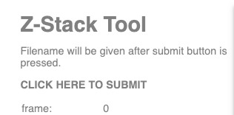

Your uploaded file will record all the changes that you have made to the tracking file and send us the revised file. After you press submit, you will reach the final page, which will show the filename of the file that you edited. Please copy the name of the file, and paste it on the input line below. Finally, click the 'finished' button on this page to complete the task.

**If Caliban doesn't work properly**

First, make sure you have clicked inside the viewing window, which may solve your issue. This is a new tool that may still have some flaws with how it works. The tool may have been updated since the last time you accessed it. If the tool does not seem to load correctly, try refreshing the page without cached data. If this does not work and you encounter an error that prevents you from finishing correcting the file, please select that option instead of submitting your file.